|  |
| --- |
| Barrel chest |
|  |

# What is barrel chest?

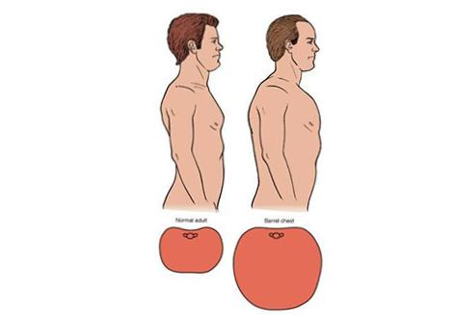happens when the lungs become overfilled (hyper inflated) with air like a balloon  as they work harder. This keeps the rib cage open or expanded for a long time

## Causes

Barrel chest is usually caused by lung condition as**:**

**Cystic****fibrosis**

 Cystic fibrosis (CF) is an inherited (genetic) condition that affects the lungs and other parts of the body.

This disease makes the mucus in the lungs thick and sticky. The thick mucus can clog the lungs, making it harder to breathe. As an individual works harder to breathe, they may develop barrel chest.

**Asthma**

Asthma is the most common cause of a barrel chest in children and adults. Approximately 7.8 percent of people in the United States have asthma. This chronic condition happens when inflammation  swelling and mucus narrows the airways of the lungs. This makes it difficult to breathe. When the airways get very blocked the lungs can over-inflate leading to a barrel chest.

 Some children with severe asthma may also have stomachs that look sunken in. This is because the muscles around and under the lungs are working harder to get air into the lungs. Seasonal allergies, colds, and flu can worsen symptoms in adults and children with asthma.

**COPD**

Chronic obstructive pulmonary disease (COPD) is an umbrella term for several kinds of lung diseases that occur when airflow is blocked from the lungs. This can happen because of lung swelling, scarring, mucus, and other damage. Symptoms include wheezing, difficulty breathing, shortness of breath, and barrel chest.

 Most people with COPD have a history of other lung problems like emphysema, chronic bronchitis, and smoker’s cough. Studies show that children with severe asthma have a higher risk of developing COPD in adulthood.

**Emphysema**

Emphysema is a lung condition that happens when the alveoli , little air sacs or bubbles at the ends of small breathing tubes in the lungs  are damaged or destroyed. This can happen from smoking, pollution, chemicals, and other irritants getting into the lungs.

 Alveoli air sacs are where the blood goes to get oxygen and give off carbon dioxide. When the alveoli are destroyed, large spaces form in the lungs. This makes it harder for the body to get oxygen. The lungs try to help by breathing and holding in more air, leading to a barrel chest.

**Arthritis**

 Arthritis in the rib, back, and chest wall joints can lead to a barrel chest. This is more common in older adults but can happen in children in rare cases. It happens when the ribs and back get so stiff or inflamed they get stuck in an inhale or open position.

Different kinds of arthritis can cause barrel chest, including:

1. osteoarthritis
2. rheumatoid arthritis
3. costochondritis, which is arthritis in the ribs
4. juvenile idiopathic arthritis

**Genetic** **conditions**

 Other rare genetic conditions can affect the rib cage and bones in the back, triggering a barrel chest.

 These inherited conditions include:

1. scoliosis
2. pectus carinatum
3. Marfan syndrome
4. Dyggve-Melchior-Clausen syndrome
5. 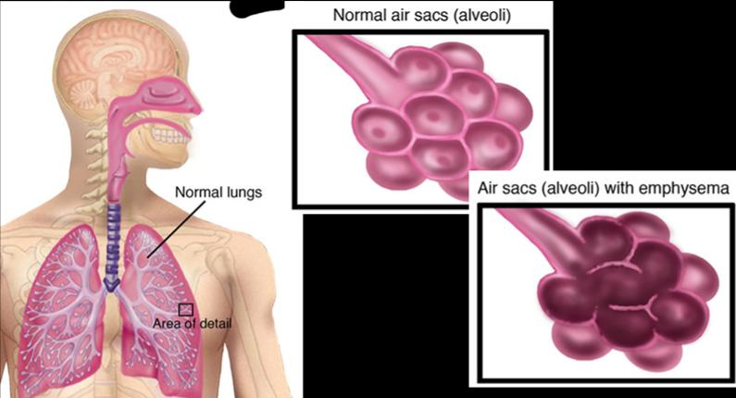sialidosis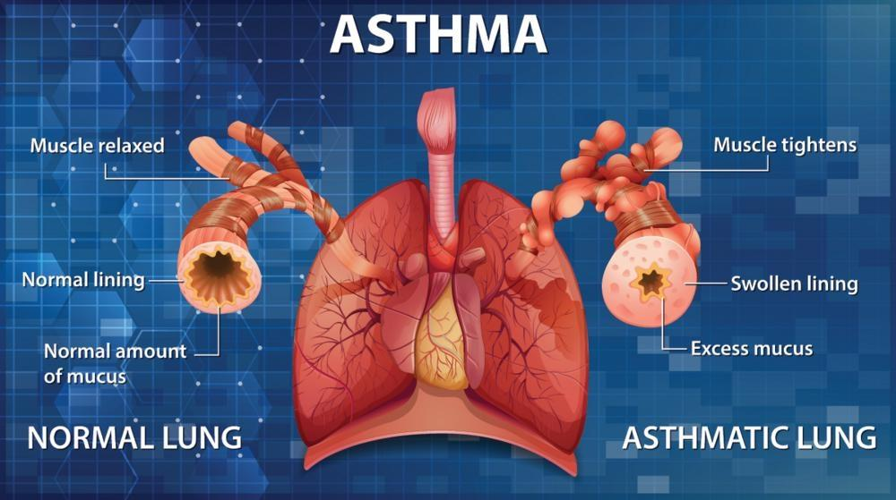

**symptoms** **of** **barrel** **chest** ?

1. difficulty breathing
2. coughing
3. wheezing
4. lung mucous or phlegm
5. gasping
6. back soreness
7. bronchitis
8. difficult moving or exercising
9. low oxygen levels
10. high carbon dioxide
11. shortness of breath levels
12. sore or stiff chest

**How** **is** **diagnosed**?

Your doctor will likely be able to tell if you have a barrel chest just by looking at you. You may also have an X-ray of your chest and back to confirm.

if you have an underlying lung condition, your doctor may recommend lung function tests like spirometry to see how well your lungs are working. You may also need a blood test to check your blood gases and inflammation levels. You may need more tests to find out what is causing your barrel chest.

A barrel chest can be diagnosed by your family doctor. You may also need to see a lung specialist, called a [pulmonologist](https://www.healthline.com/health/what-is-a-pulmonologist), or an arthritis specialist, called a [rheumatologist](https://www.healthline.com/health/rheumatoid-arthritis/what-is-a-rhuematologist), depending on the cause of this symptom

**Treatment**

While there is no specific treatment for barrel chest, for many people, treating the underlying health condition may significantly reduce barrel chest. If you have a lung condition like asthma or COPD, you will need daily medications to help keep it under control. Managing lung diseases can help prevent barrel chest and other symptoms.

Your doctor may also recommend anti-inflammatory medications and a special diet to help reduce swelling in your lungs and joints. Exercise therapy like swimming, stretches, and yoga may also help.

There is not yet a common treatment to repair a barrel chest. However, researchers are studying ways to repair the rib bones with surgery to help heal a barrel chest in people who have this symptom.